How to Drive to Pabbay House, Back
From Stornoway Airport.
Approx length of journey 10 miles.
Journey time 25/30 mins
Please note: sign posts are in Gaelic with English subtitles.
0miles
0.5 miles
0.75 miles
2.75 miles
3.00 miles
3.07 miles
4.0 miles
5.0miles

- Turn left to Exit car park at Airport
- At Mini roundabout take 2nd exit.
- At Junction take Right turn signposted Steornabhagh
- At Mini Roundabout take 2nd exit
- At Roundabout take 2nd exit. Signposted Port Nis A857
- At Roundabout take 2nd exit. Signposted Port Nis A875
- At Roundabout take 2nd exit. Signposted Barbabhas A857
- At Junction take right turn. Signposted Tolastadh B895
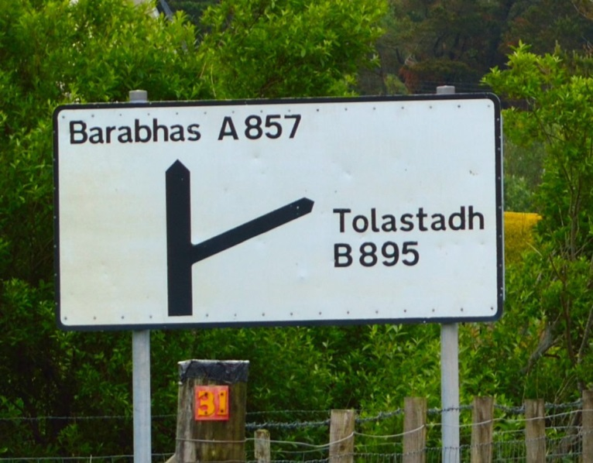
- Stay on the main Road B895 for 5 miles. Pass Tonga, Sgire a Bhac, Back Football and Recreation Club, Shop and Petrol station and a large Church on Left hand side.
- Take left turn at 2nd junction past the Church signposted Sraid A’ Bhac and Am Poileagan 10 miles
Pabbay House on Left hand side. 12 houses into the village with No 23 on the gate. Parking on opposite side of the road. 10.5 miles

How to Drive to Pabbay House, Back
From Tarbert (Harris) Ferry Terminal
Approx length of journey 43.5 miles.
Journey time 70 mins
Please note: sign posts are in Gaelic with English subtitles.
- Exit Tarbert Ferry Terminal. Take Left Turn.
Signposted Steornabhagh A859 0miles
- Take Right Turn
Signposted Steornabhagh A859 0.5 miles
Drive up through Harris and Lewis
- Continue on A859 until you reach Stornoway
Proceed until Roundabout. At roundabout take 1st exit. 37 miles
Signposted Barabhas A857
- At junction take right turn. Signposted Tolastadh B895 38 miles
- Stay on the main Road B895 for 5 miles. Pass Tonga, Sgire a Bhac, Back Football and Recreation Club, Shop and Petrol station and a large Church on Left hand side.
- Take left turn at 2nd junction past the Church signposted Sraid A’ Bhac and Am Poileagan 43 miles
Pabbay House on Left hand side. 12 houses into the village with No 23 on the gate. Parking on opposite side of the road. 43.5 miles

How to Drive to Pabbay House, Back
From Stornoway Ferry Terminal
Approx length of journey 8 miles.
Journey time 20 mins
Please note: sign posts are in Gaelic with English subtitles.
- Leave Ferry Terminal. Take a Left turn.
Signposted Port Nis A857 0 miles
- At roundabout take 2nd exit.
Signposted Port Nis A857 0.5 miles
- At roundabout take 1st exit
Signposted Port Nis A857 0.75 miles
- At Roundabout take 2nd exit.
Signposted Port Nis A875 1.5 miles
- At Roundabout take 2nd exit.
Signposted Barbabhas A857 1.75 miles
- At junction take right turn.
Signposted Tolastadh B895 2.75 miles
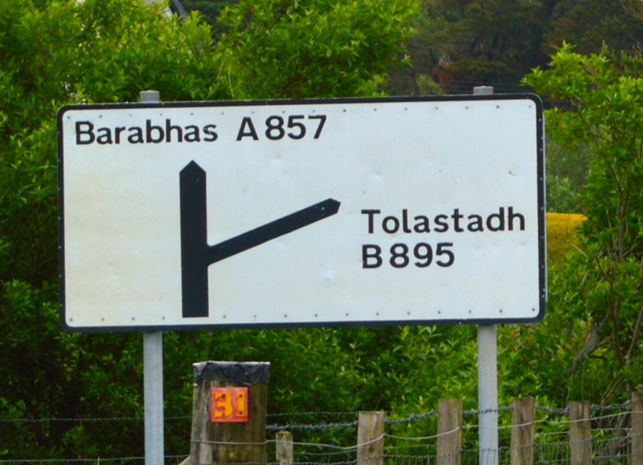
Stay on the main Road B895 for 5 miles. Pass Tonga, Sgire a Bhac, Back Football and Recreation Club, Shop and Petrol station and a large Church on Left hand side.
- Take left turn at 2nd junction past the Church signposted Sraid A’ Bhac and Am Poileagan 7.75 miles
Pabbay House on Left hand side. 12 houses into the village with No 23 on the gate. Parking on opposite side of the road 8 miles

